**Check for snyd variabel**

Racerspil.gd

Test om det virker

**Ny Game over**

Fjernes fra _proces

Og tilføjes i start_passeret

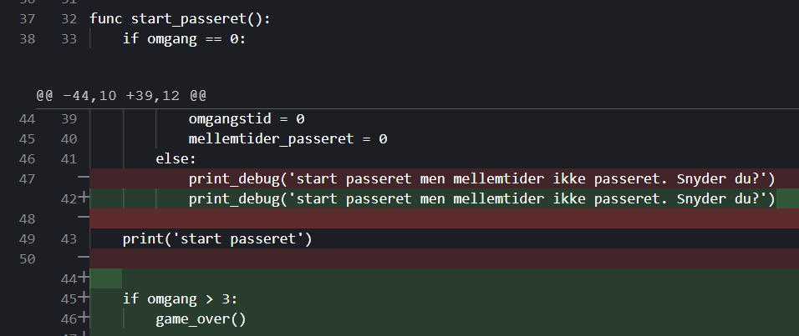

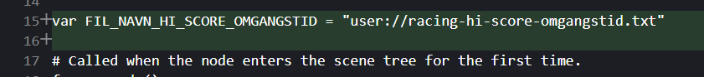

**Du har slået high-score**



